In-Depth LinkedIn Optimization With Marketing Management Techniques
Canadian Logistics Industry

Maria Juliana Velasquez Recio
[Department, Institution]
MRKT-621: Marketing Management
[Instructor Name]
[Assignment Due Date]
In-Depth LinkedIn Optimization With Marketing Management Techniques
This paper uses marketing management tools to rebuild my professional brand on LinkedIn for a single market, freight transportation within Canadian logistics. That is the field where I want to work in Metro Vancouver. The industry research and the job postings I reviewed show what recruiters and operations managers look for, and those findings decided how I present my experience.

Research and Analysis

Target Industry: Canadian Logistics
This project looks at logistics in Canada, mainly freight transportation and the digital services that firms use to book and coordinate shipments. Innovation, Science and Economic Development Canada (2018) defines logistics as the planning, implementation, and control of the movement and storage of goods, services, and related information. In day-to-day business that means linking suppliers, plants, warehouses, carriers, and customers. Trucks, trains, and ships move the freight. Distribution still fails if inventory is not controlled, orders are not processed on time, or the people in a shipment work with wrong information.
The industry is closely tied to the domestic economy and to international trade, as transportation and warehousing contributed CAD 96.5 billion, or 4.3% of national GDP, in 2024 (Transport Canada, 2025b). In that same year Canada’s international merchandise trade reached approximately CAD 1.55 trillion, of which, measured by value, road transportation carried 46%, marine transport 21.1%, air 11.6%, and rail 10.5%, so the first set of figures describes the output of the transportation and warehousing sector, whereas the second describes the value of the merchandise flows that the network moves.
Mordor Intelligence (2026) estimates that freight transportation accounted for 60.88% of the Canadian freight and logistics market in 2025, and that share, combined with the growing use of digital freight marketplaces, makes this field a reasonable starting point for examining employers and the qualifications they look for. Freightera, a Vancouver-based business-to-business platform on which shippers compare and book freight, offers a useful example of this type of service (Freightera, n.d.-a).

Historical Market Performance, 2021–2025
Ken Research (n.d.) estimates that the market increased from USD 97 billion in 2021 to USD 112 billion in 2025, a cumulative gain of approximately 15.5%, and more than half of that USD 15 billion increase came in 2022 alone, since annual growth stayed below 3% from 2023 onward.
Table 1
Estimated Canadian Logistics Market Value, 2021–2025
Year | USD billions | Year-over-year growth
2021 | 97 | 7.8%
2022 | 105 | 8.2%
2023 | 108 | 2.9%
2024 | 111 | 2.8%
2025 | 112 | 0.9%
Note. Data from Ken Research (n.d.).
Figure 1
Estimated Market Value of the Canadian Logistics Industry, 2021–2025
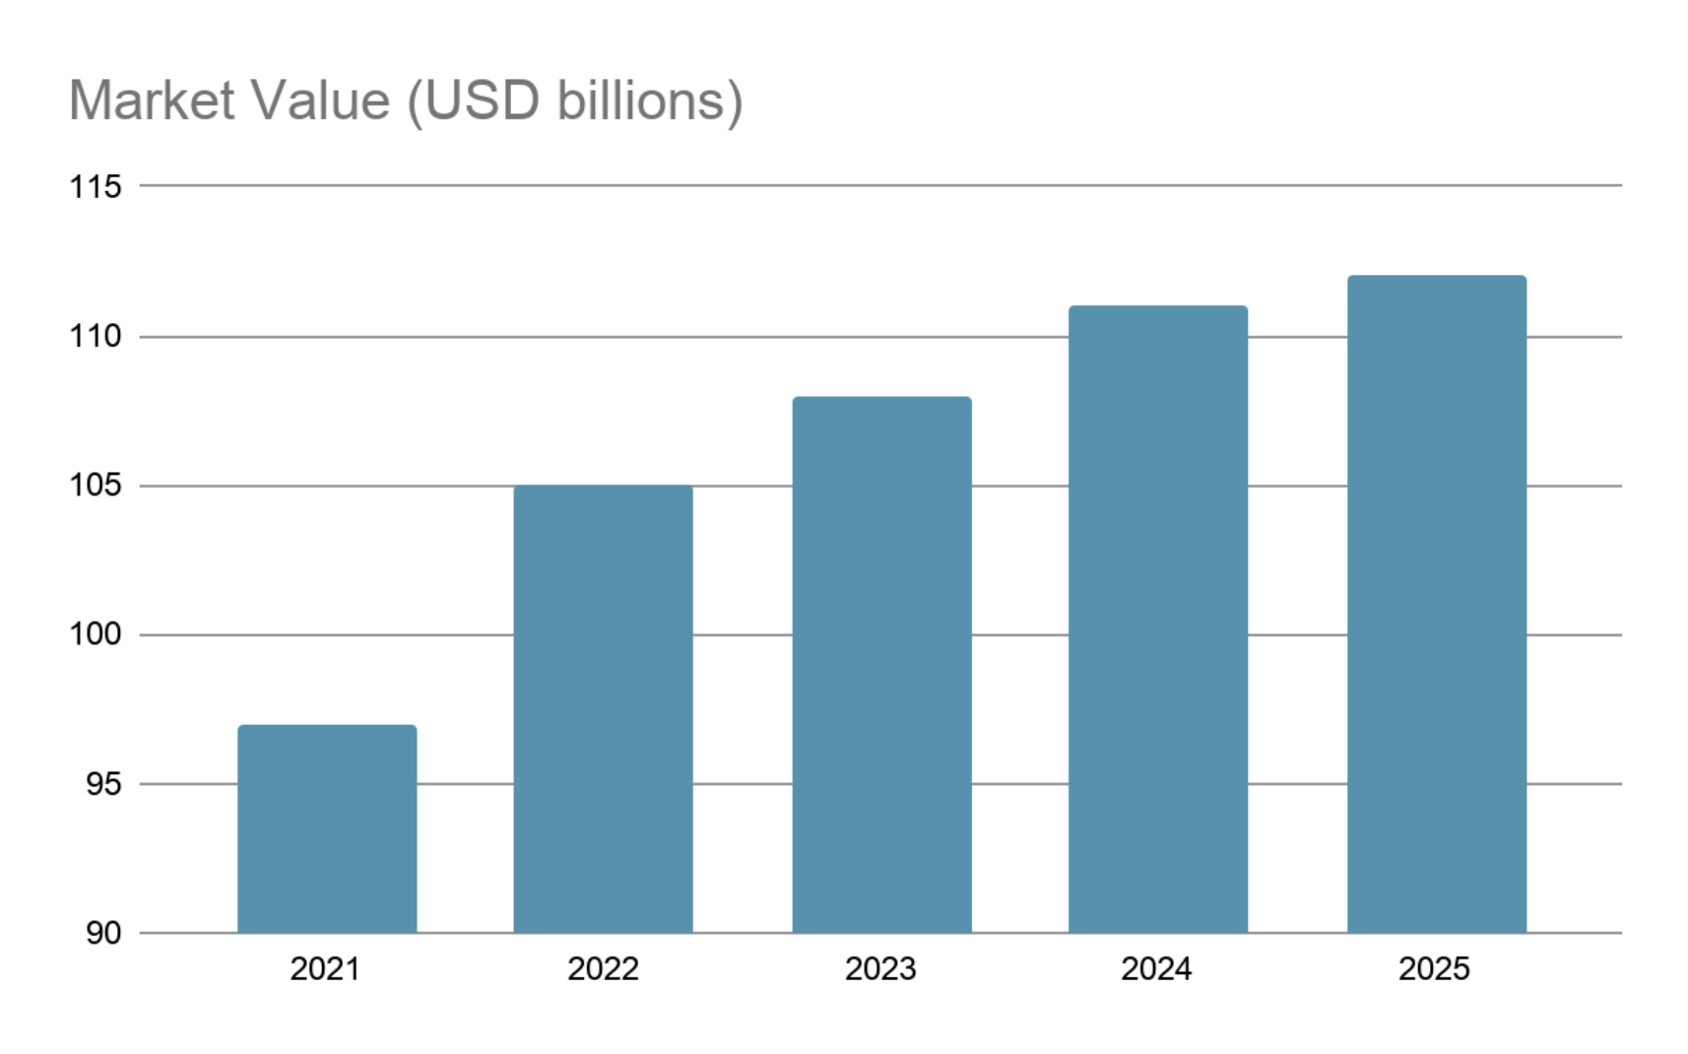
Note. Data from Ken Research (n.d.).

2021: Recovery Exposed Supply-chain Weaknesses
Freight demand came back once the first COVID-19 restrictions eased. Transport Canada (2022) recorded more port container traffic and more truck crossings than in 2020. The network was still fragile. Containers were scarce, overseas sailings ran late, and wildfires and severe flooding in British Columbia cut key routes. A container travelling from Shanghai to Toronto through West Coast ports took 34.5 days on average that year, against 25.9 days in 2019 (Transport Canada, 2026).

2022: Strong Market Value, Persistent Congestion
In 2022 the market estimate rose to USD 105 billion, the largest annual gain of the period (Ken Research, n.d.). Disruption in world supply markets raised export demand for Canadian commodities, while imported goods kept terminals and inland connections under pressure (Transport Canada, 2023). The average container journey from Shanghai to Toronto reached 39.9 days, the longest of the five years (Transport Canada, 2026). Part of the higher market value came from freight rates and tight capacity. It does not show better service or more goods moved.

2023: Weaker Goods Demand and Labour Disruption
Growth slowed to 2.9% in 2023 as inflation, higher financing costs, and softer spending reduced demand for some imported and industrial goods (Ken Research, n.d.; Transport Canada, 2024). The July labour dispute at British Columbia ports was especially disruptive, since merchandise imports cleared through those ports fell 18.5% relative to June and exports departing them fell 23.0%, according to figures that Statistics Canada (2023) did not seasonally adjust, and although transit from Shanghai to Toronto improved to 35.0 days, part of that relief reflected the reduced congestion that came as demand eased (Transport Canada, 2026).

2024: Recovery Differed by Corridor
The market estimate reached USD 111 billion in 2024, an increase of 2.8% (Ken Research, n.d.), while freight volumes recovered in several transport modes with results that varied across Canadian gateways, as Transport Canada (2025a) reported higher container activity at major ports alongside continued interruptions from labour disputes and extreme weather. Online retail, for its part, remained a meaningful source of distribution demand, since Statistics Canada (2026a) measured CAD 73.7 billion in e-commerce operating revenue for 2024, a figure 9.0% above that of 2023.

2025: Trade Reorientation Reshaped Freight Flows
Although the market estimate edged up just 0.9% in 2025, to USD 112 billion (Ken Research, n.d.), the geography of freight changed considerably, as Transport Canada (2026) found that Canadian merchandise exports to the United States fell about 5% while exports to other markets climbed roughly 16%. Truck entries into Canada decreased by about 5% and U.S.-linked rail freight weakened, but marine gateways gained from overseas trade, with the Port of Vancouver handling a record 170.4 million metric tonnes, 8% more than in 2024, and with container transit from Shanghai to Toronto improving to 33.3 days, although it remained noticeably slower than in 2019 (Transport Canada, 2026).

Interpretation of the Historical Trend
Over these five years, a rebound in demand first exceeded the practical capacity of parts of the network, after which shipping conditions normalized, freight activity weakened on some routes, and service reliability gradually improved, until by 2025 trade policy was changing the geography of freight demand, putting transborder trucking under pressure while ocean-oriented corridors gained business. Employers who went through this period need people who can track a shipment, plan for disruption, keep customers informed, and change routes when a corridor slows down. Growth in shipment numbers says little about that work.

Current Market and Outlook, 2026–2031
Mordor Intelligence (2026) values the freight and logistics market at USD 111.66 billion in 2025 and USD 116.63 billion in 2026. Its forecast reaches USD 145.05 billion by 2031, a compound annual growth rate of 4.45%.
Figure 2
Projected Canadian Logistics Market Value, 2026–2031
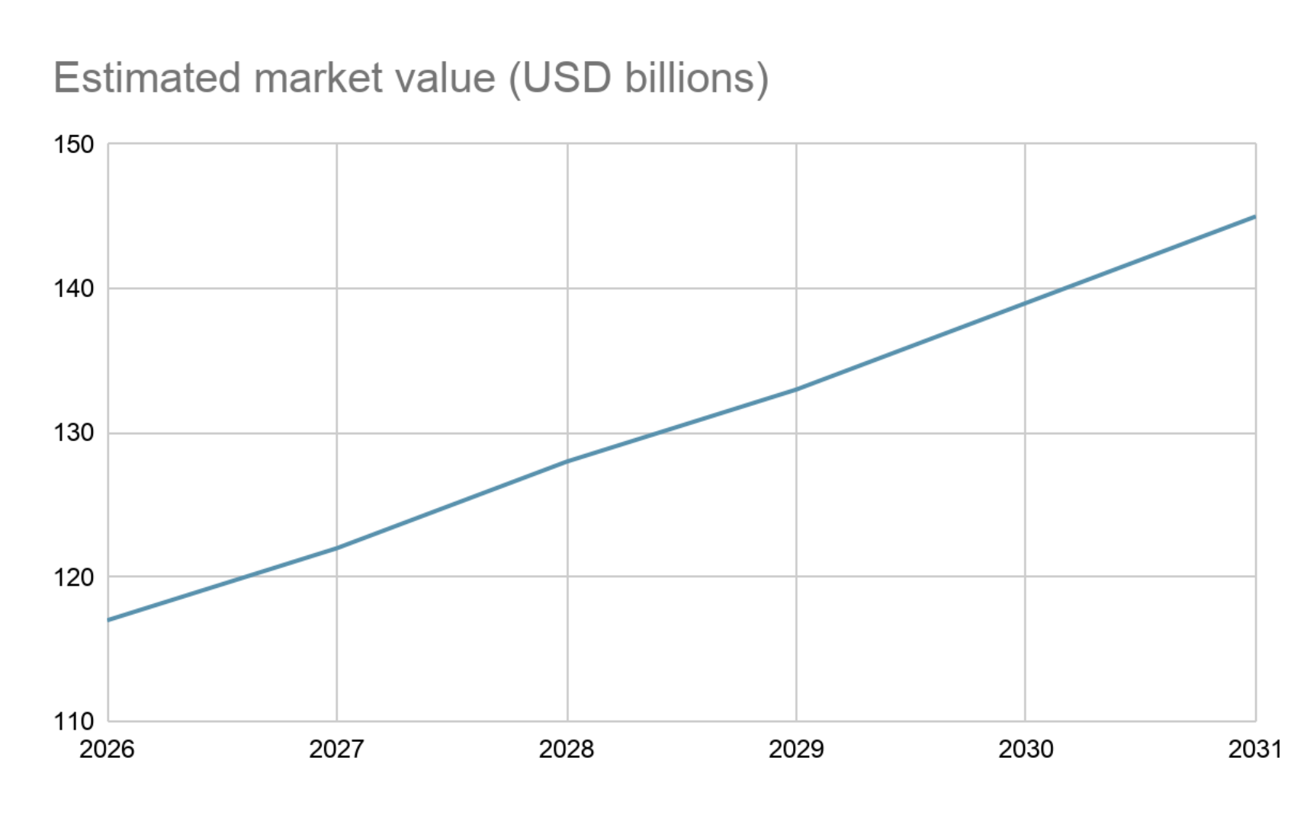
Note. Data from Mordor Intelligence (2026). Values for 2027–2030 are interpolated at the 4.45% compound annual growth rate implied by the forecast.
Conditions during 2026 help explain both the opportunity and the risk contained in that projection, since real GDP increased 0.8% in the second quarter, supported by exports, spending, and investment (Statistics Canada, 2026b), while the Bank of Canada (2026) projects 1.0% real GDP growth for the year and warns of persistent energy-price pressures and uncertainty over U.S. trade policy. The Bank's October report also expects inflation of 2.9% in 2026 and 3.1% in 2027. Road carriers could then face higher fuel and input costs and thinner margins, even if the nominal value of logistics services keeps rising.
Online shopping should keep demand high for fulfilment, warehousing, and parcel delivery. Mordor Intelligence (2026) expects courier, express, and parcel services to grow faster than the market as a whole, in line with the rise in online retail documented by Statistics Canada (2026a). Trade diversification helps ports, rail, and intermodal carriers, above all when exporters look for routes that do not run through the United States (Transport Canada, 2026).
Digital tools let companies plan routes, flag exceptions, and coordinate shipments. They pay off only when they fit into daily work and the staff know how to use them. Freightera already lets shippers compare carriers and handle documents online (Freightera, n.d.-a). Emissions matter too. Transport produced about 22% of Canada’s greenhouse gas emissions in 2024, counting passenger and freight activity (Transport Canada, 2026). Fuel efficiency, better use of network capacity, and lower-emission modes may soon weigh as much as price and service when a customer chooses a logistics provider.
I read the outlook as cautiously positive. Demand is moving toward specialized services that depend on data, but labour availability, energy costs, climate-related disruption, and North American trade conditions could slow the pace of growth.

Market Segmentation and Selected Segment
For this assignment I segmented logistics by service, not by customer demographics. I used the four service categories in Mordor Intelligence (2026), which are freight transportation, freight forwarding, warehousing and storage, and courier, express, and parcel services.
Table 2
Main Service Segments of Canadian Freight and Logistics
Segment | Core activities | Employment relevance
Freight transportation | Truck, rail, air, and sea movement | Dispatch, routing, fleet and transport coordination
Freight forwarding | Arranging domestic or international shipments | Carrier selection, documentation and customer service
Warehousing and storage | Inventory storage and order handling | Warehouse supervision, inventory and reporting
Courier, express, parcel | Time-sensitive packages and last-mile delivery | Hub operations and distribution planning
Note. Segments from Mordor Intelligence (2026).
I chose freight transportation, with a focus on road freight and digital brokerage. The segment produced 60.88% of market revenue in 2025, and road freight alone made up 60.97% of freight transportation revenue (Mordor Intelligence, 2026). Freightera, whose platform offers LTL, FTL, flatbed, and cross-border options, shows how this segment works in practice (Freightera, n.d.-a).

Leading Companies Operating in Canada
Table 3 compares major Canada-based transport groups with multinational operators relevant to my target career paths, and its financial figures must be read with care, since the consolidated results of CN, CPKC, and TFI include operations outside Canada and multinational companies such as FedEx, UPS, DHL, and Amazon do not report a directly comparable Canada-only logistics revenue measure in the sources examined.
Table 3
Selected Logistics Employers and Main Activities
Company or group | Principal activity
CN | Rail freight and intermodal services
CPKC | Rail freight across Canada, the United States, and Mexico
TFI International | Truckload, LTL and transportation services
Mullen Group | Trucking, logistics and warehousing
Cargojet | Air cargo services
Canada Post / Purolator | Postal, courier and parcel delivery
FedEx / UPS / DHL | Express delivery, freight and contract logistics
Amazon | E-commerce fulfilment and distribution
Freightera | Digital freight marketplace and shipment coordination

Among the five transport companies selected for financial comparison, CN reported CAD 17.304 billion in 2025 revenue, ahead of CPKC at CAD 15.078 billion (Canadian National Railway, 2026; Canadian Pacific Kansas City, 2026), while TFI International reported USD 7.885 billion, which, converted at the Bank of Canada’s 2025 average rate of CAD 1.3978 per U.S. dollar, amounts to approximately CAD 11.02 billion (Bank of Canada, n.d.; TFI International, 2026). Mullen Group and Cargojet followed with CAD 2.134 billion and CAD 0.993 billion, respectively (Cargojet, 2026; Mullen Group, 2026).
Figure 3
2025 Consolidated Revenue of Selected Freight Transportation Companies
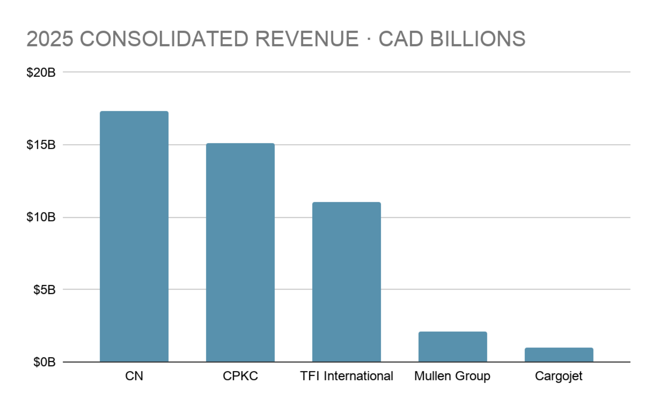
Note. TFI International reported USD 7.885 billion, converted at CAD 1.3978 per U.S. dollar (Bank of Canada, n.d.). Other values come from the company reports cited in the text.
Ranking the companies by growth instead of size changes the order. Mullen Group grew 7.3% in 2025, and its management credits acquisitions more than stronger freight demand (Mullen Group, 2026). CPKC grew about 3.7% and CN 1.5%. Cargojet fell about 0.8% and TFI International 6.1% (Canadian National Railway, 2026; Canadian Pacific Kansas City, 2026; Cargojet, 2026; TFI International, 2026). Canada Post’s revenue dropped 4.7% after labour uncertainty cost it parcel business (Canada Post, 2026). These companies have different business models and revenue bases, so Figure 4 shows annual change and does not rank operational efficiency.
Figure 4
Annual Revenue Growth for Selected Logistics Companies, 2024–2025
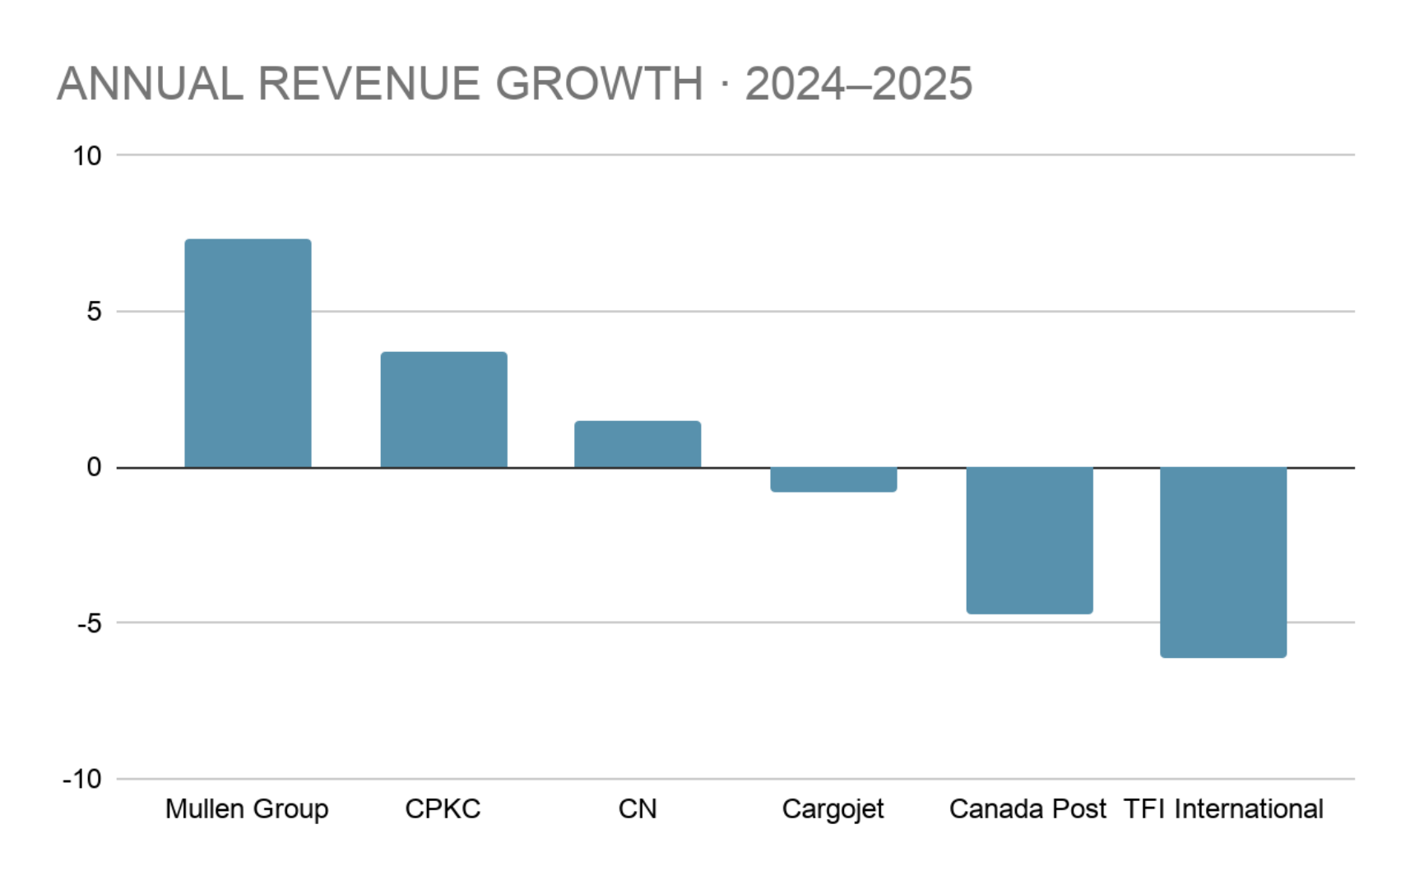
Note. Change in reported annual revenue. Sources are cited in the text.
Freightera does not appear in Figure 4. Its marketplace is the kind of freight coordination I want to do, and in May 2025 it reported 31.4% revenue growth. That figure covers fiscal 2024 (Freightera, 2025), a different period from the other companies’ results.

Target Jobs and Employment Requirements
I started with a national sample of LinkedIn job advertisements to see how requirements change from one operating environment to another. It covers dispatch and coordination, operations supervision, digital systems, and cargo handling (Table 4).
Table 4
LinkedIn Job Sample and Selected Qualifications
Employer / job | Education or experience | Skills / certifications
CPKC · Assistant Trainmaster | Secondary school or equivalent; rail operations background is an asset | Train and yard plans, compliance, staff supervision; conductor qualification to obtain or keep
TFI / Normandin Transit · Logistics Coordinator | High school; transport experience and postsecondary study are assets | Shipment tracking, TMS, Microsoft Office, customer contact; bilingual is an asset
Canada Post · Supervisor, Operations Relief | High school plus 1 year leading a team, or 2 years in a unionized workplace | Daily scheduling, safety, productivity reports, Microsoft Office; postsecondary education is an asset
Purolator · Operations Coordinator Hub Yard | No diploma or years of experience stated; linehaul knowledge preferred | Yard checks, equipment assignments, numeracy, English, communication
Mullen Group · Senior Transportation Applications Specialist | Postsecondary study in logistics, business, or IS, or equivalent experience | TMS, ERP integration, analytics, troubleshooting, user training
FedEx Canada · Operations Administrator II | High school/GED and 2 years in customer service, clerical, or similar work | Documentation, data entry, customer service, Microsoft Office
UPS · Distribution Supervisor I | Secondary school; warehouse experience usually requested | Inventory, warehouse staff coordination, safety, reporting
DHL Supply Chain · Operations Supervisor, Distribution | Operations or leadership experience; education requirement varies | KPI monitoring, workforce planning, safety, continuous improvement
Amazon · Area Manager II | Leadership experience plus one of the education or service routes in the ad | Team leadership, performance metrics, process improvement; Lean is an asset
Note. Links to each advertisement are in Table A3.
Across the sample, coordination and customer-facing jobs keep asking for accurate documentation, Microsoft Office, shipment monitoring, and communication. Supervisory jobs add staff management and responsibility for safety. The specialized openings require railway rules, air cargo procedures, or transportation software. A broad “logistics” headline may draw attention, but for the entry and intermediate roles I selected, a recruiter needs to see proof of coordination, reporting, and systems knowledge (Government of Canada, n.d.-a; see Appendix A).
That led me to focus on Logistics Coordinator, Transportation Coordinator, Operations Coordinator, and similar operations-support roles. Inventory Coordinator and distribution roles stay on my list as a second option.

Competencies in Metro Vancouver Job Advertisements
I then tested the choice on the local market. The sample has 10 advertisements from Vancouver, North Vancouver, Richmond, Surrey, and Burnaby, three from LinkedIn and seven from employer, staffing-firm, or local job-board sites. Six are freight or logistics jobs and four are inventory or planning jobs. A competency counted once per posting if it showed up as a requirement, an asset, or a stated duty.
All 10 advertisements describe communication with customers, carriers, colleagues, or other stakeholders, nine mention Excel or Microsoft Office, and nine refer to solving problems or resolving exceptions, while eight include operational records and eight name an operating system such as ERP, TMS, WMS, or MRP. Inventory or stock control appears in seven postings, and shipment scheduling or tracking and reporting or analysis appear in six postings each, three of which (C, E, and J) require both, so the two counts only partly overlap, given that a shipment coordinator needs to keep freight visible, whereas an inventory coordinator is more likely to work with counts, discrepancies, and performance reports.
Figure 5
Competencies Mentioned in the Metro Vancouver Job Sample
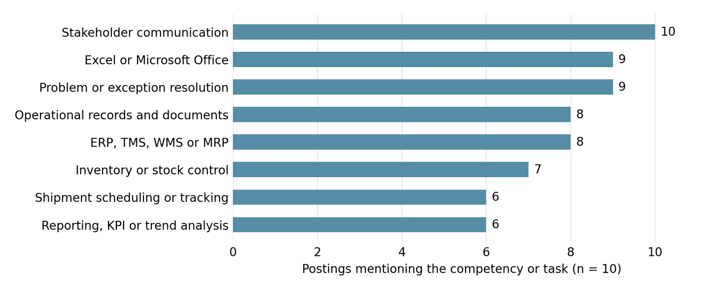
Note. The unit is one job advertisement. The 10 postings are listed and coded in Appendix A.
Table 5 sets each of these requirements next to the evidence my profile currently offers and the action I plan to take, so that every change proposed for the profile can be traced back to what local employers ask for.
Table 5
Local Requirements, Current Profile Evidence, and Planned Actions
Requirement | Ads (of 10) | Current evidence in my profile | Planned action
Stakeholder communication | 10 | Freight-status updates at GLT | Lead with it in the headline, About and GLT entry
Excel or Microsoft Office | 9 | Microsoft Office listed in Skills | Confirm the Excel functions I can use independently
Problem or exception resolution | 9 | Not yet described | Add a verified example under GLT or Garage
Operational records and documents | 8 | Not yet described | Describe the records I handled once verified
ERP, TMS, WMS or MRP | 8 | SAP ERP listed in Skills | Attach SAP ERP to the role where I used it; add other systems only with evidence
Inventory or stock control | 7 | Stock movement and replenishment at Garage | Keep in the Garage entry and Skills
Shipment scheduling or tracking | 6 | Freight-status updates at GLT | Keep in the GLT entry and About
Reporting, KPI or trend analysis | 6 | KPI-related skills, Power BI and Colombina indicator projects | Featured Power BI variance report
Note. Counts from Figure 5; posting-level codes in Table A1.

Segmentation, Targeting, and Positioning (STP)
I used segmentation, targeting, and positioning to decide which part of the labour market to address and what I can offer it, understanding segmentation as the grouping of audiences by their needs, targeting as the choice of the groups to prioritize, and positioning as the definition of the value I want those groups to associate with my profile (Gomez Albrecht et al., 2023).

Professional Audience Segmentation
The people who may encounter my profile fall into four groups, each of which plays a different role in the hiring process and looks for different information, as summarized in Table 6.
Table 6
Professional Audience Segments for LinkedIn
Audience | Role in the hiring process | Priority information
Talent acquisition / HR | Search, screen and coordinate applications | Matching titles, qualifications and skills
External recruiters / headhunters | Source candidates for client vacancies | Relevant specialization and availability
Logistics / operations managers | Evaluate operational fit and supervise teams | Examples of coordination, reliability and problem solving
Industry peers / contacts | Share vacancies, refer candidates and exchange expertise | Genuine interests, network participation and useful work

Priority Target Audiences
Recruiters filling logistics, road freight, and distribution jobs in Metro Vancouver come first. They screen people for roles that share a title but not the same requirements, and they reach profiles through LinkedIn search and its location filters (LinkedIn, n.d.-d). Local employers such as DSV, Rolls Right, and Hecny Transportation Canada are posting jobs that fit what I have done. My secondary audience is formed by the operations managers who evaluate candidates for these roles and who, once a recruiter has shortlisted me, need to see evidence of the work itself.

Marketing Personas
I built two personas from the vacancy descriptions and from LinkedIn’s search guidance. Each one stands for a reader who needs different information from my profile (Figure 6).
Figure 6
Marketing Personas for My LinkedIn Strategy
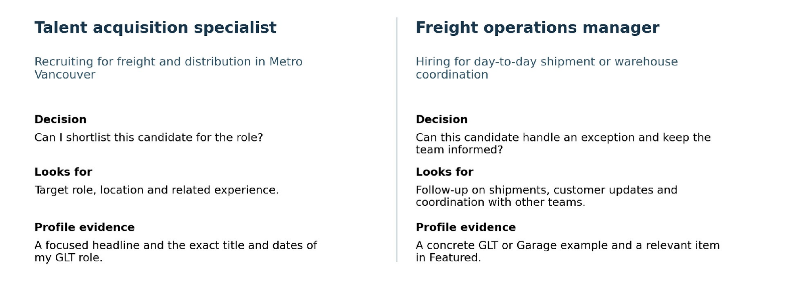
Note. Composite personas based on the vacancies in Appendix A and on LinkedIn’s search guidance.
The recruiter persona is a talent acquisition specialist screening logistics and distribution applicants in Metro Vancouver, for whom a broad headline means having to infer what I coordinated and whether my experience fits the vacancy. The operations manager persona runs a freight or warehouse team. This reader wants someone who keeps an order moving when the plan changes, and will look for a concrete case, such as a handoff I managed or a status update I sent.

Positioning Statement
I want to be known for freight coordination and inventory operations. Data analytics supports that work but is not the headline. My jobs at GLT and Garage give me two examples of following operations through from start to finish. My industrial engineering degree and my postgraduate study at Douglas College explain my interest in reporting, inventory accuracy, and process improvement.
In the profile, freight and inventory experience comes first. The headline names that direction, and the About and Experience sections describe the work behind it. Any tool or performance claim I add will be tied to a role, project, or result that I can talk about in an interview.
My formal positioning statement is aimed at logistics recruiters and operations managers in Metro Vancouver. To them, I am a logistics coordinator trained in industrial engineering who keeps freight and stock visible. Three things back up that claim, namely the freight-status updates I sent at GLT Logistics, the stock movement and replenishment I coordinate at Garage Clothing, and my postgraduate studies in data analytics at Douglas College.

Marketing Mix: The 4Ps of Personal Branding
I applied the four Ps (Gomez Albrecht et al., 2023) to my LinkedIn strategy. Product is the experience I offer. Price is my basis for discussing pay. Place is where I will reach employers, and Promotion is how I will show my work and join conversations. Table 8 lists the decision for each element.

Product: The Professional Value Offered
What I offer combines freight coordination at GLT Logistics, stockroom operations at Garage Clothing, and earlier work in purchasing, planning, and operational indicators. The mix is useful in practice. I can talk about a shipment from the customer’s side and also about the internal work of processing and replenishing stock. The profile will describe those duties and include one work sample that shows my analytical skills.

Price: Salary Benchmark
The Government of Canada Job Bank reports national hourly wages of CAD 21.63 to 44.79 for transportation logistics coordinators, with a median of CAD 29.49, and of CAD 19.90 to 45.00 for transportation logistics supervisors, with a median of CAD 28.85 (Government of Canada, n.d.-b, n.d.-c). These observations mainly cover 2023–2024 and the Job Bank pages were updated in November 2025, while Table 7 converts the same hourly ranges into annual wages on the basis of 2,080 working hours per year.
Table 7
Canadian Wages for Selected Logistics Occupations
Occupation | Low (CAD/year) | Median (CAD/year) | High (CAD/year)
Transportation logistics coordinator | $44,990 | $61,339 | $93,163
Transportation logistics supervisor | $41,392 | $60,008 | $93,600
Note. Annual values assume 2,080 hours per year (40 hours × 52 weeks). Data from Government of Canada (n.d.-b, n.d.-c).
I will use CAD 50,000–65,000 as a preliminary comparison range for coordination roles and then adjust my expectations to each job’s scope, location, and schedule, considering that DSV’s coordination posting in Richmond started at CAD 47,000, whereas Sandvik’s inventory position in Surrey advertised CAD 60,000–75,000 (DSV, n.d.; Sandvik, n.d.). The two sources answer different questions. Job Bank describes the occupation across Canada, and a posting shows what one employer is offering.

Place: LinkedIn
LinkedIn is where I will present my work history and where people in logistics can find me. When an advertisement sends me to an employer’s career site, I will apply there. LinkedIn notes that a focused title, an accurate location, and relevant skills help a recruiter judge fit (LinkedIn, n.d.-a, n.d.-d).
I will follow Freightera, Purolator, Rolls Right, and DSV to see which roles they post and what their teams talk about. Before applying, I will read each posting closely, especially when it asks for a specific transport mode, language, or operating system.

Promotion: Evidence and Sustainable Values
Short posts and comments will show how I think about operations. One post could explain what a shipment update should contain when an ETA changes. Another could show how I would check a discrepancy in an inventory count. I will only use public data or examples I am allowed to share, and I will reply to comments that ask a specific question (LinkedIn, n.d.-c).
The market research also provides a relevant sustainability topic, since Transport Canada (2026) reports that transportation accounted for about 22% of Canada’s greenhouse gas emissions in 2024 and Freightera (n.d.-b) describes options for lower-emission shipping, which would allow me to discuss how load consolidation or mode selection affects both service and emissions and to relate that question to my interest in planning.
Table 8
4Ps Applied to the Proposed LinkedIn Strategy
Element | Decision | How it will be evidenced
Product | Freight coordination and inventory operations | GLT and Garage duties, education and a work sample
Price | CAD 50,000–65,000 as an initial comparison | Check the location, scope, schedule and posted pay
Place | LinkedIn and employer career pages | Focused profile, local job searches and direct applications
Promotion | Practical examples and sector conversations | Posts, comments, a Featured item and relevant connections

LinkedIn Profile Review
The market analysis gave me the criteria for reviewing my profile, namely that a recruiter should be able to recognize the role I am targeting and that an operations manager should be able to see how my experience relates to the work, so I began with LinkedIn’s guidance on completing a profile and then compared my existing wording with the skills and duties found in the local advertisements.

Recommendations for a Logistics Profile
LinkedIn recommends a recognizable professional photo, a background image, an About section that explains the professional story, and Experience and Skills sections that reflect career goals (LinkedIn, n.d.-a). For the photo, that means good light, a plain background, and a crop that keeps my face clear on a phone screen. The banner can use the space next to the portrait to name my field. I will check both on a laptop and on a phone.
The headline should name the job I want to be found for, in words that match my experience. LinkedIn personalizes people search and uses profile attributes and filters such as location (LinkedIn, n.d.-d), so the wording of the vacancies is a good place to start. “Logistics Coordinator,” “Freight Transportation,” and “Inventory Management” are more specific than “Logistics.” I would put the role in the headline, describe the work in About and Experience, and attach a short list of skills to the jobs where I used them.
The About section can tie my jobs together. It says what I have done, what I can offer, and which roles I want. The Experience section goes into detail about what I handled and who relied on that information, for example a status update, a call with a carrier or warehouse, or a problem that held up a shipment.
If I have a verified result, I can add its scope and period. If I only know the responsibility, an accurate description is enough.
Skills and Featured do different jobs. A skill such as SAP ERP says what I can use, and a work sample shows how I apply a method. LinkedIn allows work, education, skills, and media to be added to a profile (LinkedIn, n.d.-a). I would feature a college project or a clearly labelled practice dataset on inventory analysis, with the question, the data used, and the operational decision it supports.

Analysis of My Current Profile

Photo and Banner
My current photo shows my face clearly against a light background, and I would keep it as long as it is recent. The banner is easy to read and already says “Logistics Coordinator,” which fits my target roles. It also gives “Data Analyst” a line of its own and points in two directions at once. I would make “Freight Coordination and Inventory Operations” the main message and let my education and work samples carry the analytical side.

Headline and About
My headline reads “Industrial Engineering | Data Analytics | Logistics.” It names my training and interests, but a recruiter has to open my experience to find out that I have coordinated freight. I would change it to “Logistics Coordinator | Freight Transportation and Inventory Management | Industrial Engineering” and keep my current job title in the Experience section.
The location is set to Canada. If Metro Vancouver is where I am based and looking for work, I will change it. My personalized URL and the English and Spanish versions of the profile stay as they are, since they already work well.
The About section starts with “I am an Industrial Engineer with an emphasis on operations.” It covers purchasing, planning, stock, and software, yet the GLT and Garage examples appear elsewhere and part of the text goes to general traits. I would keep the purchasing and planning background and use the opening lines to connect my experience to freight and inventory.

Proposed About Text
I’m an industrial engineer with experience in freight coordination, inventory, and retail operations. At GLT Logistics, I kept customers up to date on their freight and passed shipment updates to everyone involved. In my current role at Garage Clothing in Burnaby, I coordinate stock movement, replenishment, and shipment processing so the sales floor stays stocked.
Before that, at Colombina, my work was in purchasing and planning, and I took part in projects to improve operational indicators. I also completed a postgraduate program in data analytics at Douglas College. Now I’m looking for logistics and inventory coordination roles in Metro Vancouver, where my experience can support daily operations and reporting.

Experience and Education
The opening lines of my Garage and GLT entries already point to relevant work, so they only need sharpening. For Garage I would write “Coordinate daily stockroom work, moving and replenishing inventory and processing shipments so the sales floor stays stocked.” For GLT the line would be “Kept customers updated on freight status and shared shipment details with the team coordinating each delivery.” Once I can describe it accurately, each role will get a second example, such as a shipment exception I followed up or a stock discrepancy I handled.
At Colombina I supported projects to improve indicators and helped standardize responsibilities, and that work ties into the operations and reporting side of my search. The titles and dates stay exactly as they are, along with my industrial engineering degree and the Douglas College program. Google Project Management stays under Courses.

Skills, Languages and Featured
My skills list already includes Freight Transportation, Inventory Management, SAP ERP, Microsoft Office, Microsoft Power BI, and KPI-related skills. That is a better start than a list of personal qualities. I would move Logistics Coordination, Freight Transportation, and Inventory Management to the top and link SAP ERP, reporting, or planning to the jobs where I can explain how I used them.
Some skills appear twice, once in English and once in Spanish (Planning and Planificación, for example), and some of the duplicates carry endorsements. I will review those endorsements before merging labels, and the language information will stay in the Languages section.
Featured is my chance to show inventory analysis. One option is a short Power BI report that compares recorded stock with counted stock by product, shows how I calculate the variance, and explains which discrepancy I would investigate first.

Activity and Recommendations
Most of my visible activity is short congratulations to contacts. These comments keep me in touch with colleagues, but they tell a recruiter little about my interest in logistics. LinkedIn suggests sharing professional knowledge and starting conversations (LinkedIn, n.d.-c). I will keep interacting with colleagues and add comments that make a practical point, for example what a dispatch team needs to know when an ETA changes. I could also ask a former colleague or supervisor to recommend me for specific work we did together.

Profile Assessment With ChatGPT and Resume Worded
I used ChatGPT (OpenAI, 2026) to compare my headline, About, Experience, and Skills sections with the duties in the local advertisements. I asked it to sort the requirements into those my profile already supports, those that are present but hard to find, and those that need more evidence. According to the comparison, my GLT and Garage entries already cover freight communication, stock movement, and shipment processing. The gap was in where that evidence appeared. My headline was broad, my About section did not connect the two jobs, and some relevant skills were scattered across duplicate entries.
The comparison also flagged claims I need to check. Microsoft Office is listed, but I still have to confirm which Excel functions I can use on my own. SAP ERP is listed too, while the advertisements name several other systems. I will add TMS, WMS, CargoWise, or advanced Excel only when I can show where I used them, since a term missing from my profile is not automatically a weakness. Appendix C contains my prompt and explains how I reviewed the output.
I will run Resume Worded’s LinkedIn Review (Resume Worded, n.d.) before and after the changes, following the steps in Appendix C. Its scores and section feedback can then be compared with the ChatGPT results and with the requirements in Table 5.

LinkedIn Analytics and Search Keywords
I recorded the first-day values on November 11, 2026. The dashboard showed 1,085 followers, no post impressions in the seven-day window, three profile viewers over 90 days, and six search appearances between October 27 and November 2, while the profile itself read “500+ connections.” These numbers do not measure the same thing. Search appearances count how often I turn up in searches, profile views count the people who opened the profile, and impressions count how often my content was seen (LinkedIn, n.d.-b, n.d.-e).
Right now my profile uses Industrial Engineering, Data Analytics, Logistics, Freight Transportation, Inventory Management, SAP ERP, Microsoft Office, and Power BI as search terms, and Logistics Coordinator appears in the banner. In the revised profile each term goes to the section that backs it up, with “Logistics Coordinator” in my headline and GLT title, freight status updates in my About section and GLT description, and inventory management and replenishment under Garage, while reporting and SAP ERP remain where I can explain their use. Should my account show who searched for me or which terms they used, I will copy that information as it appears and keep it apart from my own keyword list, which only covers the text I wrote.
These measures will guide what I adjust. If search appearances rise and profile views stay low, I will revisit how well my headline and location match the target jobs. If views go up without new relevant connections or conversations, I will check whether my Experience and Featured sections give a reader a reason to contact me. A post with impressions but few reactions or comments will make me rethink its topic, opening, and question before I write the next one. Followers and connections show how my network changes, and I will also look at whether the new people work in the areas I selected.

Action Plan
I will first record the complete baseline and then revise the parts of my profile that affect how recruiters understand my experience, and the last day of the comparison will be the date on which I finish deploying the plan and record the final readings.
Table 9
Action Plan for My LinkedIn Profile
Stage | Action I Will Take | Evidence of Completion
Record the baseline | Save the profile and available analytics. Before editing, note the exact connections, following count, post breakdown and any seven-day view count. | Dated profile and analytics captures, baseline values and Resume Worded report if available
Revise the profile | Change the banner, headline, About text and Experience wording. Reorder skills; check the English and Spanish versions. | Before-and-after sections; list of keywords added, kept or moved
Add evidence of my work | Pick an existing analytics project or build a labelled inventory example. Add it to Featured with the decision it supports. | Featured item plus a copy or link showing the analysis and data source
Publish and interact | Post about freight updates or inventory accuracy. Comment with substance and connect with people in local logistics. | Post links; record of relevant comments and connections
Compare results | Record final analytics over equivalent windows. Compare profile text, review feedback and each post’s results. | Completed Table 10, post-by-post record and dated after evidence

First Publication Draft
A pickup is running late. What does the next person in the chain need from you?
Sending freight-status updates at GLT Logistics taught me that a good update says where the freight was last confirmed, what the new ETA is, and who owns the follow-up. With that, the customer and the operations team both know where to start.
Freight and dispatch people, when an ETA moves, what do you need to know first?
#Logistics #FreightCoordination #SupplyChain #Dispatch

Key Measurements Before and After
Table 10 sets the first-day values next to the columns I will complete on the last day of the plan.
Table 10
First-Day and Last-Day Comparison of My LinkedIn KPIs
Metric | First day | Last day | Change
 | November 11, 2026 | Date: __________
People who follow me | 1,085
Connections | 1,077
Profile viewers in 90 days | 3
Weekly search appearances | 6 (October 27–November 2)
Posts shown in the dashboard window | 0 (November 5–11)
Articles | 0
Photo posts | 0
Video posts | 0
Text, document and other posts | 0
Post impressions, seven days | 0 shown
Views by post or format, if available | Not recorded
Reactions | Not recorded
Comments | Not recorded
Keywords in my profile | First-day list in the analytics section

Every post gets a log entry with its date, format, link, impressions, views when LinkedIn shows them, reactions, and comments. I note the format because impressions and views can vary by format. Readings for different posts will be taken after the same number of days. If search appearances or views go up, the profile was more visible during that window. A recruiter message or a good discussion under a post is another kind of result. The profile and my activity will change at the same time, so I will report any difference as something observed during the plan.

Before-and-After Evidence
Appendix B holds my first-day profile and dashboard evidence. At each checkpoint I will capture the same screen or data source using the checklist in Appendix C. Every improvement I report will name the change, cite its evidence label, and state the period the metric covers.

Conclusion
Freight transportation brought in 60.88% of Canadian freight and logistics revenue in 2025. Five years of disruption have taught employers in this segment to value shipment visibility, contingency planning, and customer communication. The Metro Vancouver advertisements say the same thing, with stakeholder communication in all 10 and Excel or Microsoft Office in nine.
That is why the revised profile opens with freight coordination and inventory operations, which my jobs at GLT Logistics and Garage Clothing support, and treats data analytics as a tool for those roles. Once the action plan has run, the first-day baseline in Table 10 will show whether the profile became easier to find and more convincing for recruiters and operations managers.

References
Amazon. (2026). Area manager II, YYZ4 [Job posting]. LinkedIn. https://ca.linkedin.com/jobs/view/area-manager-ii-yyz4-at-amazon-4487056629
Aston Carter. (n.d.). Logistics coordinator [Job posting]. LinkedIn. https://ca.linkedin.com/jobs/view/logistics-coordinator-at-aston-carter-4465678704
Bank of Canada. (n.d.). Annual exchange rates. https://www.bankofcanada.ca/rates/exchange/annual-average-exchange-rates/
Bank of Canada. (2026, October 28). Monetary policy report—October 2026. https://www.bankofcanada.ca/publications/mpr/mpr-2026-10-28/
Canada Post. (n.d.). Supervisor, operations relief [Job posting]. LinkedIn. https://ca.linkedin.com/jobs/view/supervisor-operations-relief-at-canada-post-postes-canada-4474416239
Canada Post. (2026, April 20). Canada Post reports $1.57 billion loss before tax for 2025. https://www.canadapost-postescanada.ca/cpc/en/our-company/news-and-media/corporate-news/news-release/2026-04-20-canada-post-reports-157-billion-loss-before-tax-for-2025
Canadian National Railway. (2026, January 30). CN announces solid fourth quarter and year-end results. https://www.cn.ca/en/news/2026/01/cn-announces-solid-fourth-quarter-and-year-end-results/
Canadian Pacific Kansas City. (n.d.). Assistant trainmaster [Job posting]. LinkedIn. https://ca.linkedin.com/jobs/view/assistant-trainmaster-at-cpkc-4454842731
Canadian Pacific Kansas City. (2026, January 28). CPKC showcases strength of precision scheduled railroading; delivers record margins. https://investor.cpkcr.com/news/press-release-details/2026/CPKC-showcases-strength-of-Precision-Scheduled-Railroading-delivers-record-margins/default.aspx
Cargojet. (2026, February 24). Cargojet announces fourth quarter financial results. https://cargojet.com/wp-content/uploads/2026/02/CJT-Press-Release-Q4-2025.pdf
DHL Supply Chain. (2026). Operations supervisor – distribution [Job posting]. LinkedIn. https://ca.linkedin.com/jobs/view/operations-supervisor-distribution-at-dhl-supply-chain-4476976540
Domtar. (n.d.). Traffic office coordinator [Job posting]. https://jobs.domtar.com/job/Surrey-Traffic-Office-Coordinator-Brit-V3V3T3/1291715347/
DSV. (n.d.). Logistics coordinator [Job posting]. LinkedIn. https://ca.linkedin.com/jobs/view/logistics-coordinator-at-dsv-global-transport-and-logistics-4464804911
FedEx Canada. (n.d.). Operations administrator II [Job posting]. LinkedIn. https://ca.linkedin.com/jobs/view/operations-administrator-ii-at-fedex-canada-4480582792
Freightera. (n.d.-a). Company profile. https://www.freightera.com/company-profile
Freightera. (n.d.-b). Low emission green freight transport marketplace. https://www.freightera.com/green-freight
Freightera. (2025, May 5). Freightera celebrates birthday with growth and emissions cuts. https://www.freightera.com/blog/freightera-celebrates-birthday-with-growth-and-emissions-cuts/
Gomez Albrecht, M., Green, M., & Hoffman, L. (2023). Principles of marketing. OpenStax. https://openstax.org/details/books/principles-marketing
Government of Canada. (n.d.-a). Transportation coordinator in Canada: Skills. Job Bank. https://www.pe.jobbank.gc.ca/marketreport/skills/493/ca
Government of Canada. (n.d.-b). Transportation logistics coordinator in Canada: Wages. Job Bank. https://www.jobbank.gc.ca/marketreport/wages-occupation/27151/ca
Government of Canada. (n.d.-c). Transportation logistics supervisor in Canada: Wages. Job Bank. https://nt.jobbank.gc.ca/marketreport/wages-occupation/521/ca
Hecny Transportation Canada. (n.d.). Logistics operations coordinator [Job posting]. LinkedIn. https://ca.linkedin.com/jobs/view/logistics-operations-coordinator-at-hecny-transportation-canada-4488471933
Holland Imports. (n.d.). Purchasing planner and inventory analyst [Job posting]. My Delta. https://mydeltabc.ca/jobs/purchasing-planner-inventory-analyst-2740224
Innovation, Science and Economic Development Canada. (2018, July 17). Logistics in Canada. https://ised-isde.canada.ca/site/logistics-canada/en
Ken Research. (n.d.). Canada logistics market size, share & forecast, by service type, mode of transport & end-use industry, 2026–2032. https://www.kenresearch.com/canada-logistics-market
LinkedIn. (n.d.-a). Create a good LinkedIn profile. https://www.linkedin.com/help/linkedin/answer/a554351
LinkedIn. (n.d.-b). Differences between profile appearances and profile views on LinkedIn. https://www.linkedin.com/help/linkedin/answer/a7167501
LinkedIn. (n.d.-c). A guide to creating engaging LinkedIn posts. https://members.linkedin.com/create-start
LinkedIn. (n.d.-d). Order of your profile in people search results. https://www.linkedin.com/help/linkedin/answer/a521944
LinkedIn. (n.d.-e). View post analytics for your content. https://www.linkedin.com/help/linkedin/answer/a525196
Mordor Intelligence. (2026). Canada freight and logistics market size and share analysis—Growth trends and forecasts (2026–2031). https://www.mordorintelligence.com/industry-reports/canada-freight-logistics-market-study
Mullen Group. (n.d.). Senior transportation applications specialist [Job posting]. LinkedIn. https://ca.linkedin.com/jobs/view/senior-transportation-applications-specialist-at-mullen-group-ltd-4486991720
Mullen Group. (2026, February 12). Mullen Group Ltd. announces 2025 fourth quarter financial results and filing of disclosure documents. https://www.mullen-group.com/news/20260212-mullen-group-ltd-announces-2025-fourth-quarter-financial-results-and-filing-of-disclosure-documents/
Normandin Transit. (n.d.). We’re hiring: Logistics coordinator | Napierville, QC [Job posting]. LinkedIn. https://ca.linkedin.com/jobs/view/we-re-hiring-logistics-coordinator-napierville-qc-at-normandin-transit-inc-4488388406
OpenAI. (2026). ChatGPT [Large language model]. https://chatgpt.com/
Purolator. (n.d.). Operations coordinator hub yard [Job posting]. LinkedIn. https://ca.linkedin.com/jobs/view/operations-coordinator-hub-yard-at-purolator-inc-4480294803
Redwood Employment. (n.d.). Inventory control specialist [Job posting]. https://redwoodemployment.com/job/inventory-control-specialist/
Resume Worded. (n.d.). LinkedIn profile review. https://resumeworded.com/linkedin-review/
Rhenus Logistics. (n.d.). Ocean freight coordinator [Job posting]. https://www.rhenus.group/career/JR126647/
Rolls Right. (n.d.). Logistics coordinator [Job posting]. https://rollsright.ca/careers/logistics-coordinator-vancouver/
Sandvik. (n.d.). Inventory coordinator [Job posting]. My Maple Ridge. https://mymapleridgebc.ca/jobs/inventory-coordinator-3423697
Seaspan. (n.d.). Inventory coordinator [Job posting]. My Burnaby. https://myburnaby.ca/jobs/inventory-coordinator-3796615?from=employers/seaspan
Statistics Canada. (2023, September 6). Canadian international merchandise trade, July 2023. https://www150.statcan.gc.ca/n1/daily-quotidien/230906/dq230906a-eng.htm
Statistics Canada. (2026a, February 11). Annual retail trade, 2024. https://www150.statcan.gc.ca/n1/daily-quotidien/260211/dq260211b-eng.htm
Statistics Canada. (2026b, August 28). Gross domestic product, income and expenditure, second quarter 2026. https://www150.statcan.gc.ca/n1/daily-quotidien/260828/dq260828a-eng.htm
TFI International. (2026, February 17). TFI International announces 2025 fourth quarter and full-year results. https://www.sec.gov/Archives/edgar/data/1588823/000119312526054656/tfii-ex99_1.htm
Transport Canada. (2022). Transportation in Canada 2021: System performance. https://tc.canada.ca/en/corporate-services/transparency/corporate-management-reporting/transportation-canada-annual-reports/2021/system-performance
Transport Canada. (2023). Transportation in Canada 2022: System performance. https://tc.canada.ca/en/corporate-services/transparency/corporate-management-reporting/transportation-canada-annual-reports/transportation-canada-2022/system-performance
Transport Canada. (2024). Transportation in Canada 2023: System performance. https://tc.canada.ca/en/corporate-services/transparency/corporate-management-reporting/transportation-canada-annual-reports/transportation-canada-2023/system-performance
Transport Canada. (2025a). Transportation in Canada 2024: Network performance. https://tc.canada.ca/en/corporate-services/transparency/corporate-management-reporting/transportation-canada-annual-reports/transportation-canada-2024/network-performance
Transport Canada. (2025b). Transportation in Canada 2024: Role of Canada’s transportation network. https://tc.canada.ca/en/corporate-services/transparency/corporate-management-reporting/transportation-canada-annual-reports/transportation-canada-2024/role-canada-s-transportation-network
Transport Canada. (2026). Transportation in Canada annual report 2025. https://tc.canada.ca/en/corporate-services/transparency/corporate-management-reporting/transportation-canada-annual-reports/transportation-canada-annual-report-2025
UPS. (n.d.). Distribution supervisor I [Job posting]. LinkedIn. https://ca.linkedin.com/jobs/view/distribution-supervisor-i-at-ups-4484819007

Appendix A

Job Advertisement Evidence
Table A1 sets out the evidence and codes for each Metro Vancouver posting, and Table A2 links to the original advertisements. The national comparison sits in Table A3, where the postings show how supervision, regulated operations, and systems work differ from the jobs I am targeting now.
Table A1
Evidence and Coding for the Metro Vancouver Job Sample
ID and advertisement | Evidence and qualification examples | Codes
A · Rolls Right  Logistics Coordinator · Vancouver  (Rolls Right, n.d.) | Truck routing and tracking, bills of lading, Office, TMS, customer issue resolution. Relevant experience may substitute for a preferred degree. | C, D, T, X, S, P
B · Domtar  Traffic Office Coordinator · Surrey  (Domtar, n.d.) | Shipment entry and closeout, carrier emails, completed files, issue resolution with planners. SAP is an asset. | C, D, S, P
C · Rhenus Logistics  Ocean Freight Coordinator · Richmond  (Rhenus Logistics, n.d.) | Bookings, tracking, freight documents, claims, status reports. 3+ years in freight forwarding or logistics, strong ocean experience. | C, D, T, X, P, K
D · DSV  Logistics Coordinator · Richmond  (DSV, n.d.) | Truck tracking, filing, warehouse orders, load counts. Office and WMS named; Dangerous Goods Certification an asset. | C, D, T, X, S, I, P
E · Aston Carter  Logistics Coordinator · Richmond  (Aston Carter, n.d.) | Schedules, customs records, carrier performance, inventory, claims. 1–2 years of related experience; SAP and intermediate Excel listed as additional qualifications. | C, D, T, X, S, I, P, K
F · Hecny Transportation Canada  Logistics Operations Coordinator · Vancouver  (Hecny Transportation Canada, n.d.) | Tracks cross-border loads, keeps WMS inventory, follows up on exceptions. Excel and Outlook listed; working English plus Mandarin or Cantonese. | C, D, T, X, S, I, P
G · Redwood Employment  Inventory Control Specialist · Surrey  (Redwood Employment, n.d.) | Cycle counts, audit records, discrepancy investigations, ERP, inventory analysis. 5+ years in manufacturing inventory or supply chain. | C, D, X, S, I, P, K
H · Seaspan  Inventory Coordinator · North Vancouver  (Seaspan, n.d.) | Cycle counts, stock accuracy, variance analysis, KPI reporting. Advanced Excel, MRP/ERP; 5 years in manufacturing inventory and reporting. | C, X, S, I, P, K
I · Sandvik  Inventory Coordinator · Surrey  (Sandvik, n.d.) | Stock parameters, inventory counts, demand planning support, performance reporting. Inventory experience and Excel listed. | C, X, I, K
J · Holland Imports  Purchasing Planner and Inventory Analyst · Burnaby  (Holland Imports, n.d.) | Tracks factory and shipping milestones; manages POs, forecasts, inventory parameters. ERP, advanced Excel; SCMP or APICS/CPIM preferred. | C, D, T, X, S, I, P, K
Note. C = stakeholder communication, D = operational records and documents, T = shipment scheduling or tracking, X = Excel or Microsoft Office, S = ERP, TMS, WMS or MRP, I = inventory or stock control, P = problem or exception resolution, K = reporting, KPI or trend analysis.
I coded D only when a posting explicitly referred to operational records, forms, or documentation, and S when it named a system or a type of system. P needed an explicit mention of problem-solving, discrepancy investigation, or issue resolution. For K, I looked for formal reporting, performance measurement, or analysis beyond routine customer updates.
Table A2
Direct Links to the Local Job Advertisements
ID | Link to job description | Source type
A | Rolls Right · Logistics Coordinator · Vancouver | Employer or staffing firm career page
B | Domtar · Traffic Office Coordinator · Surrey | Employer or staffing firm career page
C | Rhenus Logistics · Ocean Freight Coordinator · Richmond | Employer or staffing firm career page
D | DSV · Logistics Coordinator · Richmond | LinkedIn job ad
E | Aston Carter · Logistics Coordinator · Richmond | LinkedIn job ad
F | Hecny Transportation Canada · Logistics Operations Coordinator · Vancouver | LinkedIn job ad
G | Redwood Employment · Inventory Control Specialist · Surrey | Employer or staffing firm career page
H | Seaspan · Inventory Coordinator · North Vancouver | Public copy of employer job text
I | Sandvik · Inventory Coordinator · Surrey | Public copy of employer job text
J | Holland Imports · Purchasing Planner and Inventory Analyst · Burnaby | Public copy of employer job text

Table A3
Additional LinkedIn Job Advertisements From the National Comparison
LinkedIn job advertisement | Operating context
CPKC · Assistant Trainmaster (Canadian Pacific Kansas City, n.d.) | Rail operations and supervision
Normandin Transit · Logistics Coordinator (Normandin Transit, n.d.) | Freight coordination in Quebec
Canada Post · Supervisor Operations Relief (Canada Post, n.d.) | Frontline operations supervision
Purolator · Operations Coordinator Hub Yard (Purolator, n.d.) | Parcel hub and yard coordination
Mullen Group · Senior Transportation Applications Specialist (Mullen Group, n.d.) | Specialized transportation systems
FedEx · Operations Administrator II (FedEx Canada, n.d.) | Operations administration
UPS · Distribution Supervisor I (UPS, n.d.) | Warehouse supervision
DHL Supply Chain · Operations Supervisor (DHL Supply Chain, 2026) | Distribution supervision
Amazon · Area Manager II (Amazon, 2026) | Fulfilment and team management

Appendix B

My LinkedIn Profile and Analytics Before the Changes
Figures B1 to B8 are screenshots of my profile and analytics taken on November 11, 2026. Each analytics view keeps the reporting window LinkedIn showed that day.
Figure B1
Profile Introduction and Banner
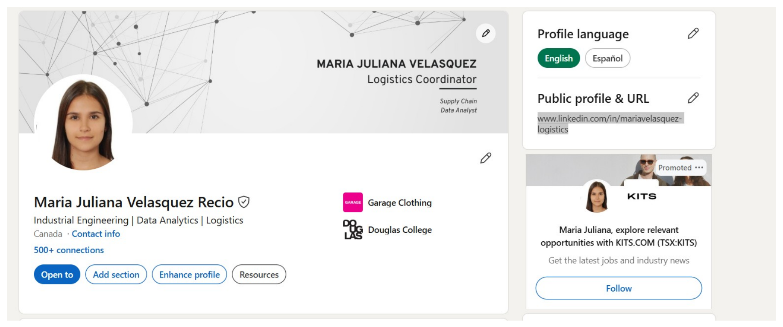
Figure B2
First-Day Analytics Dashboard
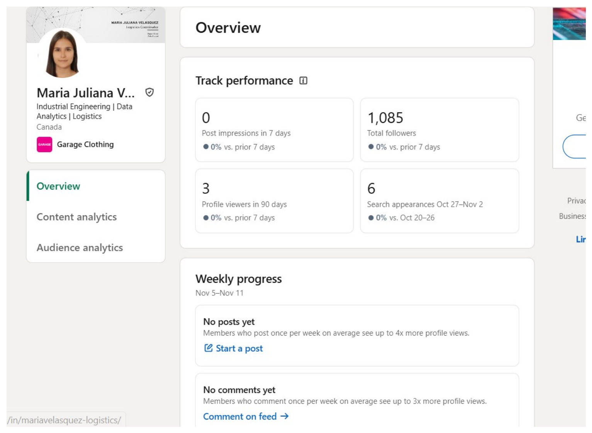
Figure B3
About Section
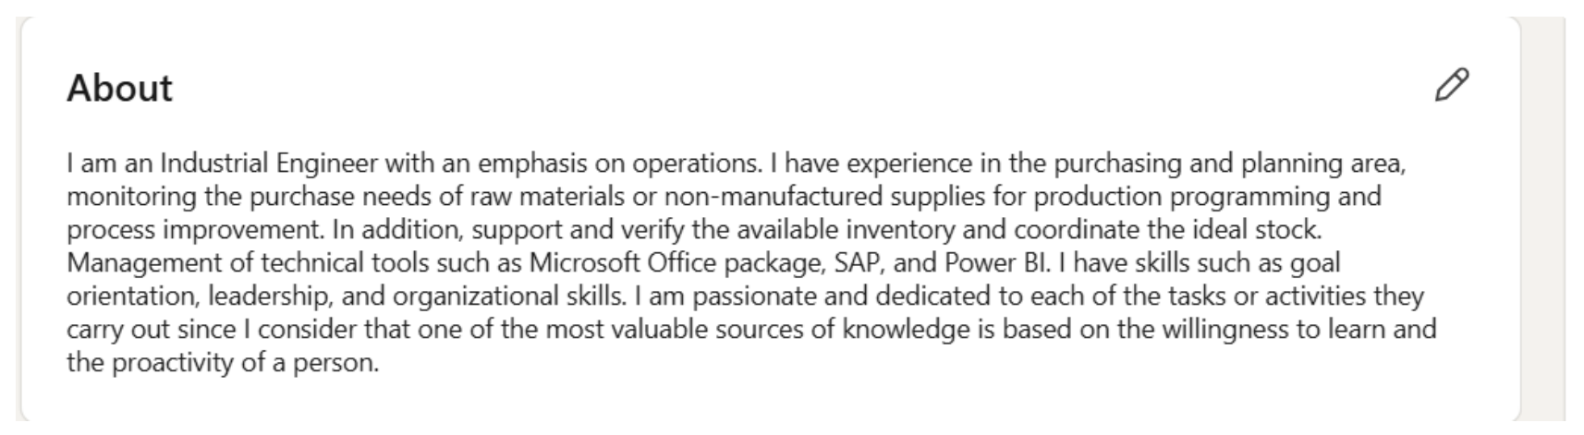
Figure B4
Recent Activity
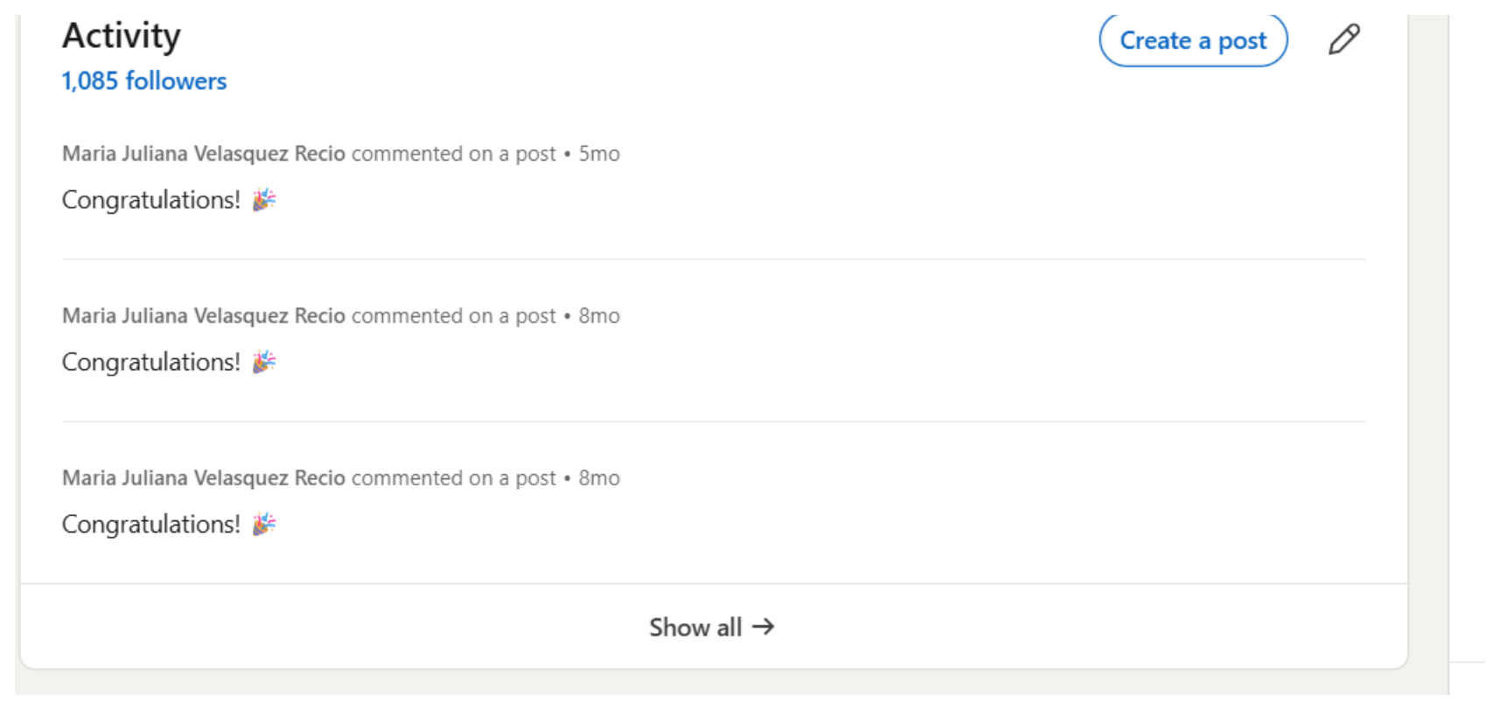
Figure B5
Current and Previous Experience
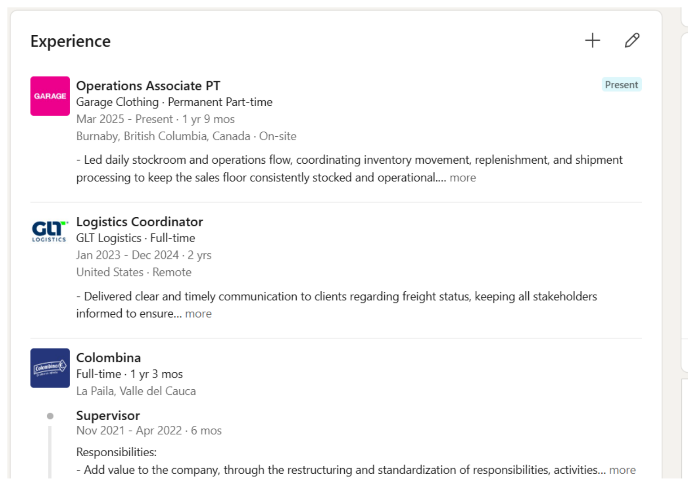
Figure B6
Earlier Experience
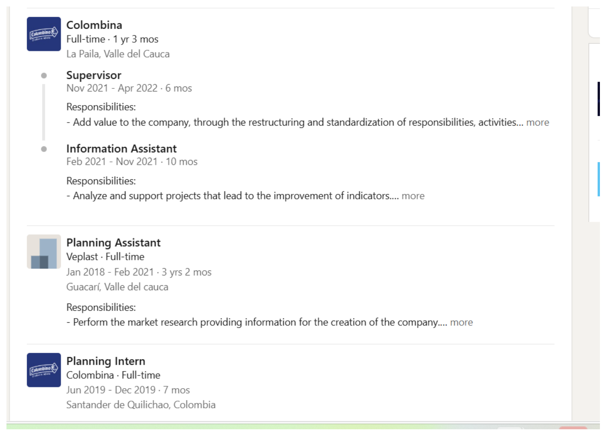
Figure B7
Education
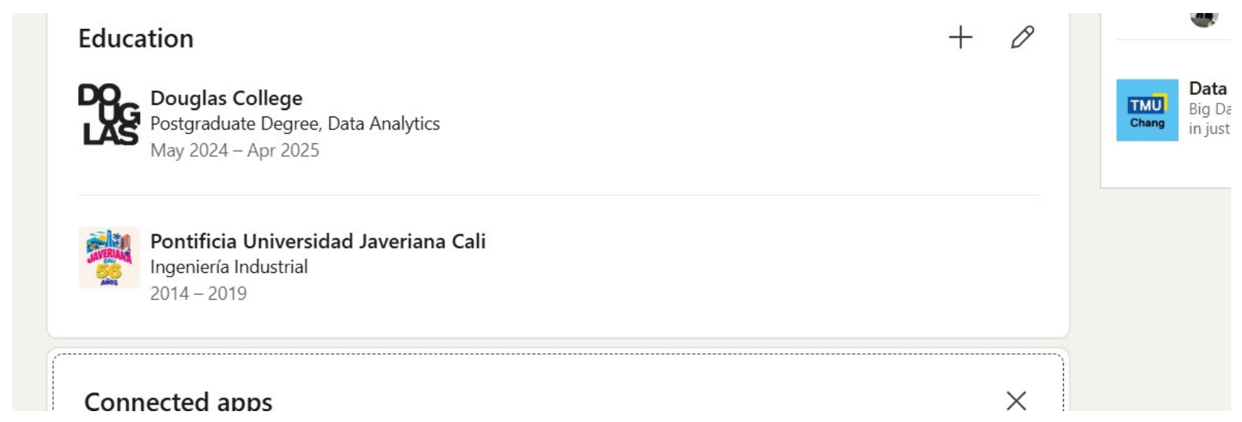
Figure B8
Course and Languages


Appendix C

Tool Assessment and Final Evidence to Add

ChatGPT Assessment Record
To reproduce my comparison, I framed the prompt for ChatGPT (OpenAI, 2026) as follows:
Compare my LinkedIn headline, About, Experience and Skills with these Metro Vancouver logistics and inventory job descriptions. Identify the requirements already supported by my work, the evidence that is hard to find, and the qualifications I should verify before adding. Suggest wording based on my actual duties.
I compared every suggestion with what I actually did at GLT and Garage and with the wording of the advertisements. What survived that check was a narrower headline, relevant experience placed higher, and skills tied to the jobs where I used them. Anything that implied advanced Excel or systems I have not confirmed was dropped.

Resume Worded Evidence
Resume Worded’s LinkedIn Review (Resume Worded, n.d.) will be run on the profile before the changes, on a saved copy of the original if the tool accepts one. I will write down the date and any overall score or section feedback, and repeat the review after the edits. The two reports, or the parts that matter, will be added here with a short note on which feedback led to a change and which target job that change serves. If the original profile can no longer be reviewed, the first report will carry the profile version and date that were actually used.

Evidence to Attach After Deployment
Table C1
Evidence for the Final Comparison
Evidence | What I Will Attach | Link to My Analysis
Profile sections | Before and after views of the headline, banner, About, Experience and Skills; Featured once published | Revised wording and the vacancy requirement each change answers
Network counts | Dated views of followers, following and exact connections when available | Same source on the first and last day; both totals and the difference in Table 10
Profile visibility | Dated views of weekly search appearances and profile viewers, with date ranges and any searcher data shown | Like periods compared; weekly views and rolling 90-day viewers on separate rows
Content performance | Posts listed by format and date, with link, impressions, reactions, views and comments when available | Individual post analytics and the overall dashboard; observation window noted
Search keywords | Exact before-and-after text, or a marked list of role titles, skills and other terms by section | What moved, what was added, and why it matches my actual experience
Tool feedback | Original and updated Resume Worded results if available; the ChatGPT notes above and my review of its suggestions | Feedback observed and suggestions used

Each piece of final evidence will be labelled by metric or profile section and dated. When a value is unavailable, the table will say so. The last-day date and results stay blank until the comparison is complete, and Table C2 records each publication and marks as unavailable any metric LinkedIn does not report.
Table C2
Record of Publications and Engagement
Date, Format and Link | Capture Date or Window | Impressions | Views | Reactions | Comments

